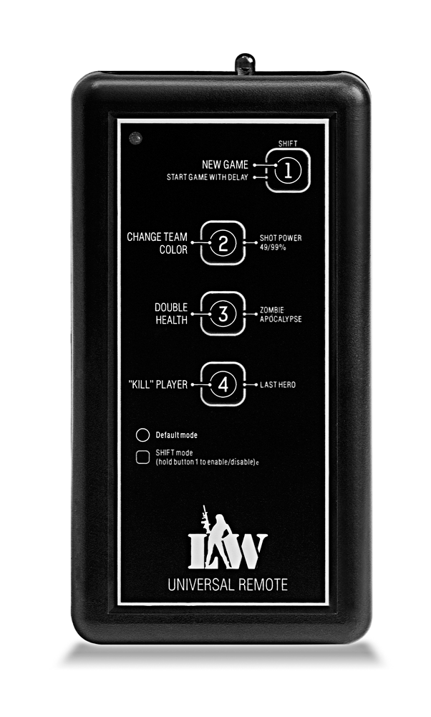

LIMITED

LIABILITY COMPANY

**LASERTAG**

SPECIFICATION

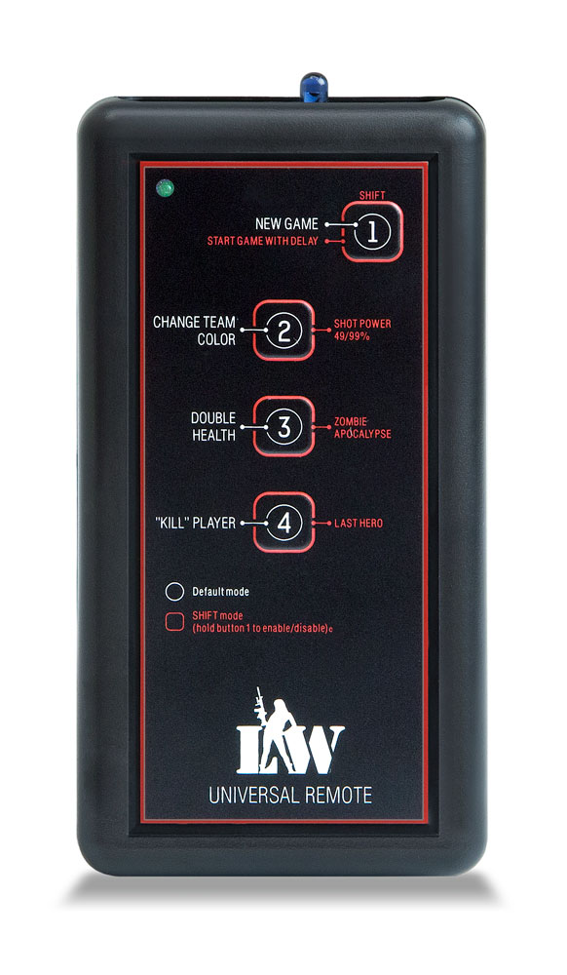

**Game set**

**Universal Remote**

Smolensk

**1. Description**

Universal remote has four buttons that helps to use laser tag equipment during the game.

**2. Scope of application**

The device is designed for laser tag weapons remote control and is used in organizing sporting events, tactical exercises, corporate and recreational activities.

**3. The set includes:**

1. Universal Remote - 1 pc.
2. Specification - 1 pc.

**4. Basic technical Data**

|  |  |
| --- | --- |
| Length, mm | **135** |
| Width, mm | **70** |
| Thickness, mm | **25** |
| Voltage | **3** |
| Weight, gr | **134** |

**5. Device**

Universal remote has a plastic frame of black color.

Inside the frame there is a battery, control junctions, mounting hardware. On the frame there are infrared emitters, quasi-censor control panel, and a power led.

**6. Maintenance**

All parts of the set must be treated with care if you want the equipment to function properly. Avoid dirt contamination and damage to IR emitters. There shouldn't be any moisture inside the frame. Change the batteries when needed. Don't hit the device.

**7. User's manual**

The Universal remote provides the ability to change game settings using software. Default settings:

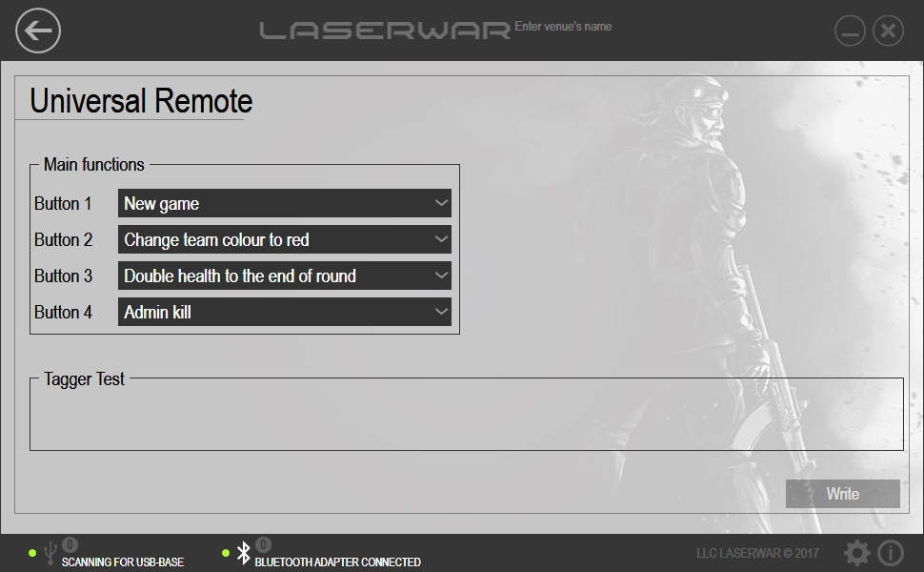

You can change default settings by using the universal remote setup program. There are 26 different settings.

Connect the USB base to your PC and enter the admin mode (to do that press the tact switch at the back of the device). Having changed settings press "write" to apply settings.

4

5

**8. Guarantee obligations**

The manufacturer guarantees the reliability of the operation of an individual LASERWAR set if the consumer has complied with the conditions of use. Technical support is provided within **12 months** of the sale date. The manufacturer undertakes to replace or repair an individual set of equipment free of charge, if the customer has complied with the rules for the device transportation, storage, operation and delivery of defective equipment to Smolensk City.

**9. Contact information**

**official website:**

www.laserwar.ru

**e-mail:** purchase date: _________________________

info@laserwar.ru

support@laserwar.ru

**skype:**

info-laserwar.ru

support laserwar.ru

______________________________________



stamp signature

**Equipment Maintenance Rules**

***1. Weather conditions.*** At the course of manufacture, we make different tests to see how well the equipment works under different weather conditions. Despite this, we strongly recommend that the equipment shouldn’t be used in the rain and at temperatures below -20 ° C.

What should I know when using the equipment in poor weather conditions?

The most important thing is to avoid getting moisture inside the device. If this happened, turn off the device, dry the equipment at room temperature for at least two hours.

***2. Power source.*** The device uses two AA batteries (1.5 V each). Don't forget to replace the batteries in time.

It is necessary to store the equipment in a well-ventilated room at temperature from + 18°C to + 30°C and relative humidity of 45-65%.

**The warranty is 14 days for batteries, speakers, and IR modules. These components are expendable materials.**

**PLEASE NOTE! In the case of improper operation of the accumulator (charging by an unrelated type of a charger), the warranty doesn't cover the battery!**

3

6

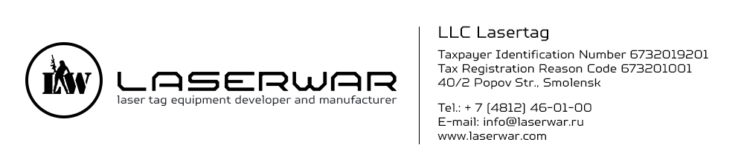

Dear Customer!

Our company welcomes and thanks you for the decision to buy our products, and is confident that the purchased device will bring you a long-term pleasure. The warranty certificate establishes the guarantee of the product in the amount provided for by the Law on consumer protection of the Russian Federation.

This warranty certificate is valid for 12 months from the purchase date of the product, and is subject to the guarantee terms.

**Warranty Terms:**

1. The guarantee is effective upon presentation of this coupon, which shall contain the serial number of the product and the date of its purchase, confirmed by the service centre.

2. These guarantee obligations apply to products acquired only from the official LASERTAG representative or the official dealer.

3. The present guarantee is invalid if the product deficiencies have occurred in the following cases:

- failure to comply with Operating instructions;

- mechanical damage;

- penetration of extraneous items, liquids, etc.;

- animal activities;

- unauthorized access to the parts of the game set by non-authorized persons;

- use of the product for purposes for which it hasn't been made;

- Acts of elements (natural disaster, fire, accidents, etc.);

- the game set malfunction in case of faulty power network and/or poor care of the product.

4. If the warranty certificate is lost, no duplicate is issued.

Information on the repairs performed during the maintenance period (completed by the Service centre performing the warranty repair works).

|  |  |
| --- | --- |
| **Date**: __________________  **Completed work:** _____________________________________________________________________  **Service centre stamp** | **Date**: __________________  **Completed work:** _____________________________________________________________________  **Service centre stamp** |
| **Date**: __________________  **Completed work:** _____________________________________________________________________  **Service centre stamp** | **Date**: __________________  **Completed work:** _____________________________________________________________________  **Service centre stamp** |
| **Date**: __________________  **Completed work:** _____________________________________________________________________  **Service centre stamp** | **Date**: __________________  **Completed work:** _____________________________________________________________________  **Service centre stamp** |

7

2